2. Install ansible and connect the nodes to master and execute the adhoc commands on ansible masternode vm and test the packages installed or not

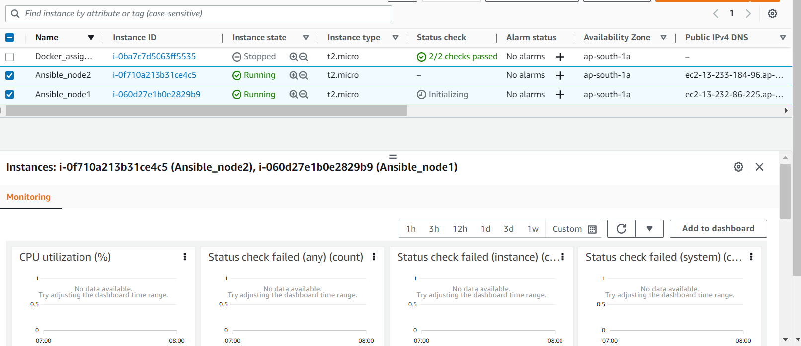

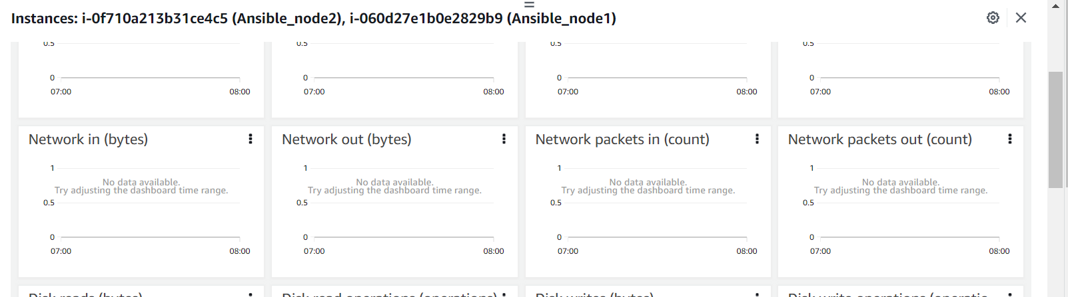

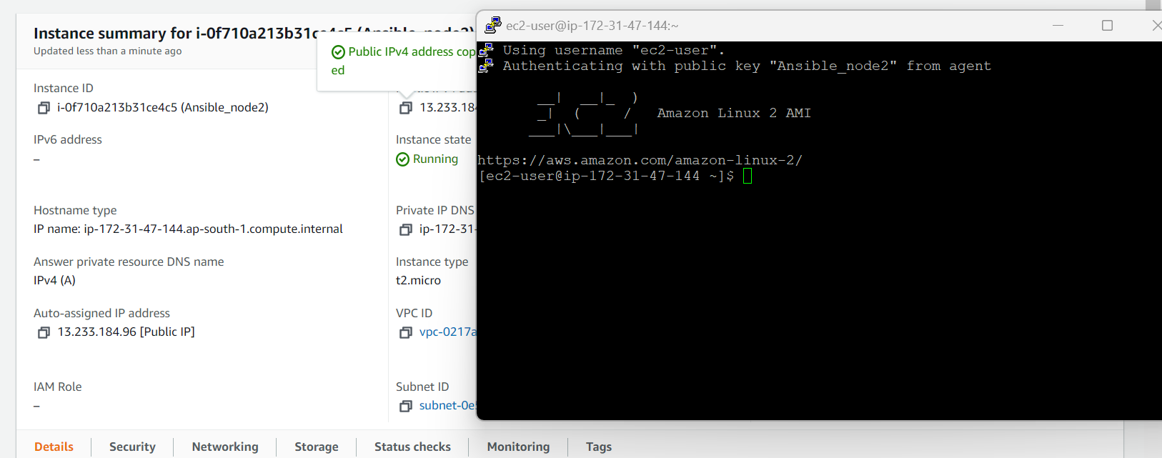

Using username "ec2-user".

Authenticating with public key "Ansible_node2" from agent

__| __|_ )

_| ( / Amazon Linux 2 AMI

___|\___|___|

https://aws.amazon.com/amazon-linux-2/

[ec2-user@ip-172-31-47-144 ~]$ sudo yum update

Loaded plugins: extras_suggestions, langpacks, priorities, update-motd

amzn2-core | 3.7 kB 00:00

No packages marked for update

[ec2-user@ip-172-31-47-144 ~]$ sudo yum install

Loaded plugins: extras_suggestions, langpacks, priorities, update-motd

Error: Need to pass a list of pkgs to install

Mini usage:

install PACKAGE...

Install a package or packages on your system

aliases: install-n, install-na, install-nevra

[ec2-user@ip-172-31-47-144 ~]$ sudo amazon-linux-extras install epel

Installing epel-release

Loaded plugins: extras_suggestions, langpacks, priorities, update-motd

Cleaning repos: amzn2-core amzn2extra-docker amzn2extra-epel

: amzn2extra-kernel-5.10

17 metadata files removed

6 sqlite files removed

0 metadata files removed

Loaded plugins: extras_suggestions, langpacks, priorities, update-motd

amzn2-core | 3.7 kB 00:00

amzn2extra-docker | 3.0 kB 00:00

amzn2extra-epel | 3.0 kB 00:00

amzn2extra-kernel-5.10 | 3.0 kB 00:00

(1/9): amzn2-core/2/x86_64/group_gz | 2.5 kB 00:00

(2/9): amzn2-core/2/x86_64/updateinfo | 539 kB 00:00

(3/9): amzn2extra-epel/2/x86_64/primary_db | 1.8 kB 00:00

(4/9): amzn2extra-kernel-5.10/2/x86_64/updateinfo | 22 kB 00:00

(5/9): amzn2extra-docker/2/x86_64/updateinfo | 8.0 kB 00:00

(6/9): amzn2extra-epel/2/x86_64/updateinfo | 76 B 00:00

(7/9): amzn2extra-docker/2/x86_64/primary_db | 99 kB 00:00

(8/9): amzn2extra-kernel-5.10/2/x86_64/primary_db | 14 MB 00:00

(9/9): amzn2-core/2/x86_64/primary_db | 68 MB 00:01

Resolving Dependencies

--> Running transaction check

---> Package epel-release.noarch 0:7-11 will be installed

--> Finished Dependency Resolution

Dependencies Resolved

================================================================================

Package Arch Version Repository Size

================================================================================

Installing:

epel-release noarch 7-11 amzn2extra-epel 15 k

Transaction Summary

================================================================================

Install 1 Package

Total download size: 15 k

Installed size: 24 k

Is this ok [y/d/N]: y

Downloading packages:

epel-release-7-11.noarch.rpm | 15 kB 00:00

Running transaction check

Running transaction test

Transaction test succeeded

Running transaction

Installing : epel-release-7-11.noarch 1/1

Verifying : epel-release-7-11.noarch 1/1

Installed:

epel-release.noarch 0:7-11

Complete!

0 ansible2 available \

[ =2.4.2 =2.4.6 =2.8 =stable ]

2 httpd_modules available [ =1.0 =stable ]

3 memcached1.5 available \

[ =1.5.1 =1.5.16 =1.5.17 ]

6 postgresql10 available [ =10 =stable ]

9 R3.4 available [ =3.4.3 =stable ]

10 rust1 available \

[ =1.22.1 =1.26.0 =1.26.1 =1.27.2 =1.31.0 =1.38.0

=stable ]

18 libreoffice available \

[ =5.0.6.2_15 =5.3.6.1 =stable ]

19 gimp available [ =2.8.22 ]

20 docker=latest enabled \

[ =17.12.1 =18.03.1 =18.06.1 =18.09.9 =stable ]

21 mate-desktop1.x available \

[ =1.19.0 =1.20.0 =stable ]

22 GraphicsMagick1.3 available \

[ =1.3.29 =1.3.32 =1.3.34 =stable ]

23 tomcat8.5 available \

[ =8.5.31 =8.5.32 =8.5.38 =8.5.40 =8.5.42 =8.5.50

=stable ]

24 epel=latest enabled [ =7.11 =stable ]

25 testing available [ =1.0 =stable ]

26 ecs available [ =stable ]

27 corretto8 available \

[ =1.8.0_192 =1.8.0_202 =1.8.0_212 =1.8.0_222 =1.8.0_232

=1.8.0_242 =stable ]

29 golang1.11 available \

[ =1.11.3 =1.11.11 =1.11.13 =stable ]

30 squid4 available [ =4 =stable ]

32 lustre2.10 available \

[ =2.10.5 =2.10.8 =stable ]

33 java-openjdk11 available [ =11 =stable ]

34 lynis available [ =stable ]

36 BCC available [ =0.x =stable ]

37 mono available [ =5.x =stable ]

38 nginx1 available [ =stable ]

39 ruby2.6 available [ =2.6 =stable ]

40 mock available [ =stable ]

41 postgresql11 available [ =11 =stable ]

42 php7.4 available [ =stable ]

43 livepatch available [ =stable ]

44 python3.8 available [ =stable ]

45 haproxy2 available [ =stable ]

46 collectd available [ =stable ]

47 aws-nitro-enclaves-cli available [ =stable ]

48 R4 available [ =stable ]

_ kernel-5.4 available [ =stable ]

50 selinux-ng available [ =stable ]

51 php8.0 available [ =stable ]

52 tomcat9 available [ =stable ]

53 unbound1.13 available [ =stable ]

54 mariadb10.5 available [ =stable ]

55 kernel-5.10=latest enabled [ =stable ]

56 redis6 available [ =stable ]

57 ruby3.0 available [ =stable ]

58 postgresql12 available [ =stable ]

59 postgresql13 available [ =stable ]

60 mock2 available [ =stable ]

61 dnsmasq2.85 available [ =stable ]

62 kernel-5.15 available [ =stable ]

63 postgresql14 available [ =stable ]

64 firefox available [ =stable ]

65 lustre available [ =stable ]

66 php8.1 available [ =stable ]

67 awscli1 available [ =stable ]

[ec2-user@ip-172-31-47-144 ~]$ sudo yum install ansible -y

Loaded plugins: extras_suggestions, langpacks, priorities, update-motd

Existing lock /var/run/yum.pid: another copy is running as pid 3414.

Another app is currently holding the yum lock; waiting for it to exit...

The other application is: yum

Memory : 333 M RSS (626 MB VSZ)

Started: Sat Dec 31 08:17:27 2022 - 00:12 ago

State : Running, pid: 3414

215 packages excluded due to repository priority protections

Resolving Dependencies

--> Running transaction check

---> Package ansible.noarch 0:2.9.27-1.el7 will be installed

--> Processing Dependency: python-httplib2 for package: ansible-2.9.27-1.el7.noarch

--> Processing Dependency: python-paramiko for package: ansible-2.9.27-1.el7.noarch

--> Processing Dependency: sshpass for package: ansible-2.9.27-1.el7.noarch

--> Running transaction check

---> Package python-paramiko.noarch 0:2.1.1-0.10.el7 will be installed

---> Package python2-httplib2.noarch 0:0.18.1-3.el7 will be installed

---> Package sshpass.x86_64 0:1.06-1.el7 will be installed

--> Finished Dependency Resolution

Dependencies Resolved

================================================================================

Package Arch Version Repository Size

================================================================================

Installing:

ansible noarch 2.9.27-1.el7 epel 17 M

Installing for dependencies:

python-paramiko noarch 2.1.1-0.10.el7 epel 269 k

python2-httplib2 noarch 0.18.1-3.el7 epel 125 k

sshpass x86_64 1.06-1.el7 epel 21 k

Transaction Summary

================================================================================

Install 1 Package (+3 Dependent packages)

Total download size: 17 M

Installed size: 105 M

Downloading packages:

warning: /var/cache/yum/x86_64/2/epel/packages/ansible-2.9.27-1.el7.noarch.rpm: Header V4 RSA/SHA256 Signature, key ID 352c64e5: NOKEY

Public key for ansible-2.9.27-1.el7.noarch.rpm is not installed

(1/4): ansible-2.9.27-1.el7.noarch.rpm | 17 MB 00:00

(2/4): python-paramiko-2.1.1-0.10.el7.noarch.rpm | 269 kB 00:00

(3/4): python2-httplib2-0.18.1-3.el7.noarch.rpm | 125 kB 00:00

(4/4): sshpass-1.06-1.el7.x86_64.rpm | 21 kB 00:00

--------------------------------------------------------------------------------

Total 40 MB/s | 17 MB 00:00

Retrieving key from file:///etc/pki/rpm-gpg/RPM-GPG-KEY-EPEL-7

Importing GPG key 0x352C64E5:

Userid : "Fedora EPEL (7) <epel@fedoraproject.org>"

Fingerprint: 91e9 7d7c 4a5e 96f1 7f3e 888f 6a2f aea2 352c 64e5

Package : epel-release-7-11.noarch (@amzn2extra-epel)

From : /etc/pki/rpm-gpg/RPM-GPG-KEY-EPEL-7

Running transaction check

Running transaction test

Transaction test succeeded

Running transaction

Installing : python2-httplib2-0.18.1-3.el7.noarch 1/4

Installing : sshpass-1.06-1.el7.x86_64 2/4

Installing : python-paramiko-2.1.1-0.10.el7.noarch 3/4

Installing : ansible-2.9.27-1.el7.noarch 4/4

Verifying : python-paramiko-2.1.1-0.10.el7.noarch 1/4

Verifying : sshpass-1.06-1.el7.x86_64 2/4

Verifying : python2-httplib2-0.18.1-3.el7.noarch 3/4

Verifying : ansible-2.9.27-1.el7.noarch 4/4

Installed:

ansible.noarch 0:2.9.27-1.el7

Dependency Installed:

python-paramiko.noarch 0:2.1.1-0.10.el7

python2-httplib2.noarch 0:0.18.1-3.el7

sshpass.x86_64 0:1.06-1.el7

Complete!

[ec2-user@ip-172-31-47-144 ~]$ ansible --version

ansible 2.9.27

config file = /etc/ansible/ansible.cfg

configured module search path = [u'/home/ec2-user/.ansible/plugins/modules', u'/usr/share/ansible/plugins/modules']

ansible python module location = /usr/lib/python2.7/site-packages/ansible

executable location = /usr/bin/ansible

python version = 2.7.18 (default, May 25 2022, 14:30:51) [GCC 7.3.1 20180712 (Red Hat 7.3.1-15)]

[ec2-user@ip-172-31-47-144 ~]$

ec2-user@ip-172-31-47-144 ~]$

[ec2-user@ip-172-31-47-144 ~]$

[ec2-user@ip-172-31-47-144 ~]$ sudo yum install python -y

Loaded plugins: extras_suggestions, langpacks, priorities, update-motd

215 packages excluded due to repository priority protections

Package python-2.7.18-1.amzn2.0.5.x86_64 already installed and latest version

Nothing to do

[ec2-user@ip-172-31-47-144 ~]$ sudo yum install openssl -y

Loaded plugins: extras_suggestions, langpacks, priorities, update-motd

215 packages excluded due to repository priority protections

Package 1:openssl-1.0.2k-24.amzn2.0.4.x86_64 already installed and latest version

Nothing to do

[ec2-user@ip-172-31-47-144 ~]$ sudo yum install docker -y

Loaded plugins: extras_suggestions, langpacks, priorities, update-motd

215 packages excluded due to repository priority protections

Resolving Dependencies

--> Running transaction check

---> Package docker.x86_64 0:20.10.17-1.amzn2.0.1 will be installed

--> Processing Dependency: runc >= 1.0.0 for package: docker-20.10.17-1.amzn2.0.1.x86_64

--> Processing Dependency: libcgroup >= 0.40.rc1-5.15 for package: docker-20.10.17-1.amzn2.0.1.x86_64

--> Processing Dependency: containerd >= 1.3.2 for package: docker-20.10.17-1.amzn2.0.1.x86_64

--> Processing Dependency: pigz for package: docker-20.10.17-1.amzn2.0.1.x86_64

--> Running transaction check

---> Package containerd.x86_64 0:1.6.8-1.amzn2 will be installed

---> Package libcgroup.x86_64 0:0.41-21.amzn2 will be installed

---> Package pigz.x86_64 0:2.3.4-1.amzn2.0.1 will be installed

---> Package runc.x86_64 0:1.1.4-1.amzn2 will be installed

--> Finished Dependency Resolution

Dependencies Resolved

================================================================================

Package Arch Version Repository Size

================================================================================

Installing:

docker x86_64 20.10.17-1.amzn2.0.1 amzn2extra-docker 39 M

Installing for dependencies:

containerd x86_64 1.6.8-1.amzn2 amzn2extra-docker 27 M

libcgroup x86_64 0.41-21.amzn2 amzn2-core 66 k

pigz x86_64 2.3.4-1.amzn2.0.1 amzn2-core 81 k

runc x86_64 1.1.4-1.amzn2 amzn2extra-docker 2.9 M

Transaction Summary

================================================================================

Install 1 Package (+4 Dependent packages)

Total download size: 69 M

Installed size: 260 M

Downloading packages:

(1/5): libcgroup-0.41-21.amzn2.x86_64.rpm | 66 kB 00:00

(2/5): pigz-2.3.4-1.amzn2.0.1.x86_64.rpm | 81 kB 00:00

(3/5): containerd-1.6.8-1.amzn2.x86_64.rpm | 27 MB 00:00

(4/5): docker-20.10.17-1.amzn2.0.1.x86_64.rpm | 39 MB 00:01

(5/5): runc-1.1.4-1.amzn2.x86_64.rpm | 2.9 MB 00:00

--------------------------------------------------------------------------------

Total 64 MB/s | 69 MB 00:01

Running transaction check

Running transaction test

Transaction test succeeded

Running transaction

Installing : runc-1.1.4-1.amzn2.x86_64 1/5

Installing : containerd-1.6.8-1.amzn2.x86_64 2/5

Installing : libcgroup-0.41-21.amzn2.x86_64 3/5

Installing : pigz-2.3.4-1.amzn2.0.1.x86_64 4/5

Installing : docker-20.10.17-1.amzn2.0.1.x86_64 5/5

Verifying : runc-1.1.4-1.amzn2.x86_64 1/5

Verifying : pigz-2.3.4-1.amzn2.0.1.x86_64 2/5

Verifying : docker-20.10.17-1.amzn2.0.1.x86_64 3/5

Verifying : containerd-1.6.8-1.amzn2.x86_64 4/5

Verifying : libcgroup-0.41-21.amzn2.x86_64 5/5

Installed:

docker.x86_64 0:20.10.17-1.amzn2.0.1

Dependency Installed:

containerd.x86_64 0:1.6.8-1.amzn2 libcgroup.x86_64 0:0.41-21.amzn2

pigz.x86_64 0:2.3.4-1.amzn2.0.1 runc.x86_64 0:1.1.4-1.amzn2

Complete!

[ec2-user@ip-172-31-47-144 ~]$ docker --version

Docker version 20.10.17, build 100c701

[ec2-user@ip-172-31-47-144 ~]$ docker version

Client:

Version: 20.10.17

API version: 1.41

Go version: go1.18.6

Git commit: 100c701

Built: Wed Sep 28 23:10:17 2022

OS/Arch: linux/amd64

Context: default

Experimental: true

Cannot connect to the Docker daemon at unix:///var/run/docker.sock. Is the docker daemon running?

[ec2-user@ip-172-31-47-144 ~]$ ansible --version

ansible 2.9.27

config file = /etc/ansible/ansible.cfg

configured module search path = [u'/home/ec2-user/.ansible/plugins/modules', u'/usr/share/ansible/plugins/modules']

ansible python module location = /usr/lib/python2.7/site-packages/ansible

executable location = /usr/bin/ansible

python version = 2.7.18 (default, May 25 2022, 14:30:51) [GCC 7.3.1 20180712 (Red Hat 7.3.1-15)]

[ec2-user@ip-172-31-47-144 ~]$

Connecting from GUI

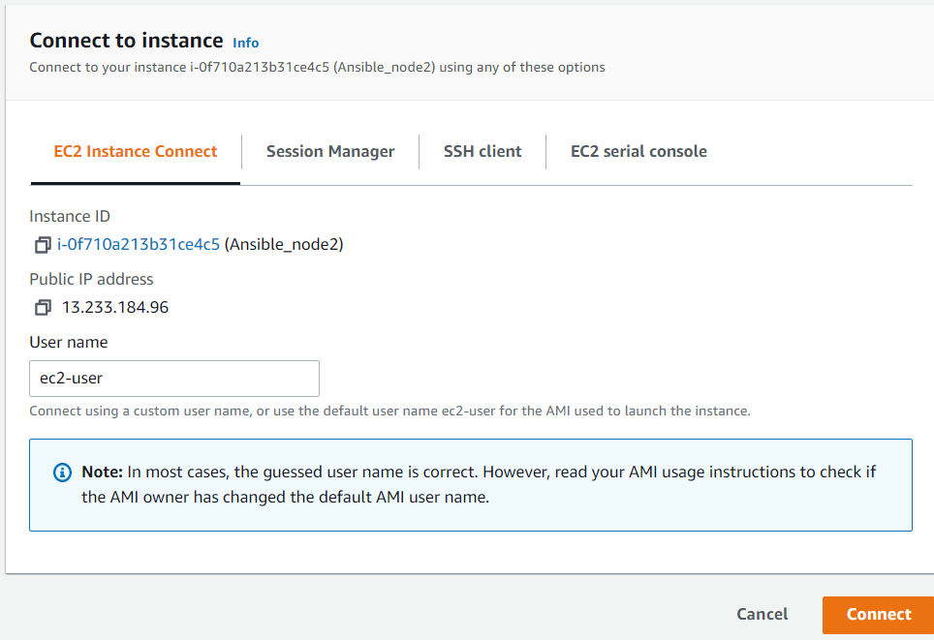

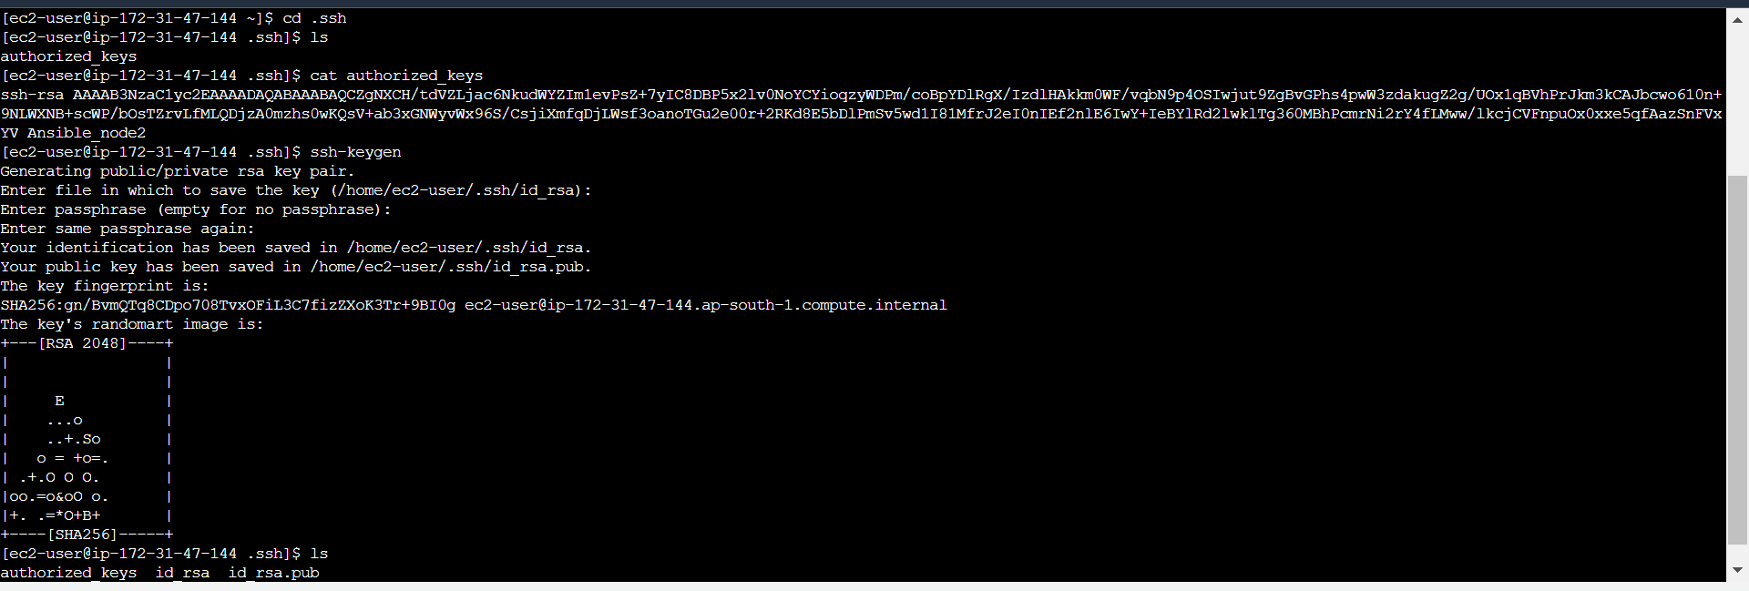

Copy ansible_node2 key to node1

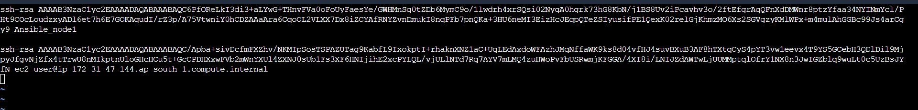



[ec2-user@ip-172-31-47-144 ~]$ cd .ssh

[ec2-user@ip-172-31-47-144 .ssh]$ ls

authorized_keys id_rsa id_rsa.pub

[ec2-user@ip-172-31-47-144 .ssh]$ cd ..

[ec2-user@ip-172-31-47-144 ~]$ ls

[ec2-user@ip-172-31-47-144 ~]$ sudo su

[root@ip-172-31-47-144 ec2-user]# cd ../../

[root@ip-172-31-47-144 /]# ls

bin boot dev etc home lib lib64 local media mnt opt proc root run sbin srv sys tmp usr var

[root@ip-172-31-47-144 /]# cd etc

[root@ip-172-31-47-144 etc]# ls

acpi cron.monthly GeoIP.conf.default iproute2 mtab printcap scl systemd

adjtime crontab gnupg issue my.cnf profile screenrc system-release

aliases cron.weekly GREP_COLORS issue.net my.cnf.d profile.d securetty system-release-cpe

aliases.db csh.cshrc groff krb5.conf nanorc protocols security terminfo

alternatives csh.login group krb5.conf.d netconfig python selinux tmpfiles.d

amazon dbus-1 group- ld.so.cache NetworkManager rc0.d services trusted-key.key

anacrontab default grub2.cfg ld.so.conf networks rc1.d sestatus.conf udev

ansible depmod.d grub2-efi.cfg ld.so.conf.d nfs.conf rc2.d setuptool.d updatedb.conf

at.deny dhcp grub.d libaudit.conf nfsmount.conf rc3.d shadow update-motd.d

audisp DIR_COLORS gshadow libnl nsswitch.conf rc4.d shadow- vimrc

audit DIR_COLORS.256color gshadow- libuser.conf nsswitch.conf.bak rc5.d shells virc

bash_completion.d DIR_COLORS.lightbgcolor gss locale.conf openldap rc6.d skel wgetrc

bashrc docker gssproxy localtime opt rc.d ssh X11

binfmt.d docker-runtimes.d hibagent-config.cfg login.defs os-release rc.local ssl xdg

chkconfig.d dracut.conf hibinit-config.cfg logrotate.conf pam.d request-key.conf statetab xinetd.d

chrony.conf dracut.conf.d host.conf logrotate.d passwd request-key.d statetab.d yum

chrony.d e2fsck.conf hostname lsm passwd- resolv.conf subgid yum.conf

chrony.keys environment hosts lvm pkcs11 rpc subuid yum.repos.d

cifs-utils ethertypes hosts.allow machine-id pki rpm sudo.conf

cloud exports hosts.deny magic plymouth rsyncd.conf sudoers

containerd exports.d idmapd.conf man_db.conf pm rsyslog.conf sudoers.d

cron.d filesystems image-id mke2fs.conf popt.d rsyslog.d sudo-ldap.conf

cron.daily fstab init.d modprobe.d postfix rwtab sysconfig

cron.deny gcrypt inittab modules-load.d ppp rwtab.d sysctl.conf

cron.hourly GeoIP.conf inputrc motd prelink.conf.d sasl2 sysctl.d

[root@ip-172-31-47-144 etc]# ls | grep ansible

ansible

[root@ip-172-31-47-144 etc]# cd ansible

[root@ip-172-31-47-144 ansible]# ls

ansible.cfg hosts roles

[root@ip-172-31-47-144 ansible]# ls -l1

total 24

-rw-r--r-- 1 root root 19985 Jan 15 2022 ansible.cfg

-rw-r--r-- 1 root root 1016 Jan 15 2022 hosts

drwxr-xr-x 2 root root 6 Jan 15 2022 roles

[root@ip-172-31-47-144 ansible]# cat ansible.cfg

# config file for ansible -- https://ansible.com/

# ===============================================

# nearly all parameters can be overridden in ansible-playbook

# or with command line flags. ansible will read ANSIBLE_CONFIG,

# ansible.cfg in the current working directory, .ansible.cfg in

# the home directory or /etc/ansible/ansible.cfg, whichever it

# finds first

[defaults]

# some basic default values...

#inventory = /etc/ansible/hosts

#library = /usr/share/my_modules/

#module_utils = /usr/share/my_module_utils/

#remote_tmp = ~/.ansible/tmp

#local_tmp = ~/.ansible/tmp

#plugin_filters_cfg = /etc/ansible/plugin_filters.yml

#forks = 5

#poll_interval = 15

#sudo_user = root

#ask_sudo_pass = True

#ask_pass = True

#transport = smart

#remote_port = 22

#module_lang = C

#module_set_locale = False

# plays will gather facts by default, which contain information about

# the remote system.

#

# smart - gather by default, but don't regather if already gathered

# implicit - gather by default, turn off with gather_facts: False

# explicit - do not gather by default, must say gather_facts: True

#gathering = implicit

# This only affects the gathering done by a play's gather_facts directive,

# by default gathering retrieves all facts subsets

# all - gather all subsets

# network - gather min and network facts

# hardware - gather hardware facts (longest facts to retrieve)

# virtual - gather min and virtual facts

# facter - import facts from facter

# ohai - import facts from ohai

# You can combine them using comma (ex: network,virtual)

# You can negate them using ! (ex: !hardware,!facter,!ohai)

# A minimal set of facts is always gathered.

#gather_subset = all

# some hardware related facts are collected

# with a maximum timeout of 10 seconds. This

# option lets you increase or decrease that

# timeout to something more suitable for the

# environment.

# gather_timeout = 10

# Ansible facts are available inside the ansible_facts.* dictionary

# namespace. This setting maintains the behaviour which was the default prior

# to 2.5, duplicating these variables into the main namespace, each with a

# prefix of 'ansible_'.

# This variable is set to True by default for backwards compatibility. It

# will be changed to a default of 'False' in a future release.

# ansible_facts.

# inject_facts_as_vars = True

# additional paths to search for roles in, colon separated

#roles_path = /etc/ansible/roles

# uncomment this to disable SSH key host checking

#host_key_checking = False

# change the default callback, you can only have one 'stdout' type enabled at a time.

#stdout_callback = skippy

## Ansible ships with some plugins that require whitelisting,

## this is done to avoid running all of a type by default.

## These setting lists those that you want enabled for your system.

## Custom plugins should not need this unless plugin author specifies it.

# enable callback plugins, they can output to stdout but cannot be 'stdout' type.

#callback_whitelist = timer, mail

# Determine whether includes in tasks and handlers are "static" by

# default. As of 2.0, includes are dynamic by default. Setting these

# values to True will make includes behave more like they did in the

# 1.x versions.

#task_includes_static = False

#handler_includes_static = False

# Controls if a missing handler for a notification event is an error or a warning

#error_on_missing_handler = True

# change this for alternative sudo implementations

#sudo_exe = sudo

# What flags to pass to sudo

# WARNING: leaving out the defaults might create unexpected behaviours

#sudo_flags = -H -S -n

# SSH timeout

#timeout = 10

# default user to use for playbooks if user is not specified

# (/usr/bin/ansible will use current user as default)

#remote_user = root

# logging is off by default unless this path is defined

# if so defined, consider logrotate

#log_path = /var/log/ansible.log

# default module name for /usr/bin/ansible

#module_name = command

# use this shell for commands executed under sudo

# you may need to change this to bin/bash in rare instances

# if sudo is constrained

#executable = /bin/sh

# if inventory variables overlap, does the higher precedence one win

# or are hash values merged together? The default is 'replace' but

# this can also be set to 'merge'.

#hash_behaviour = replace

# by default, variables from roles will be visible in the global variable

# scope. To prevent this, the following option can be enabled, and only

# tasks and handlers within the role will see the variables there

#private_role_vars = yes

# list any Jinja2 extensions to enable here:

#jinja2_extensions = jinja2.ext.do,jinja2.ext.i18n

# if set, always use this private key file for authentication, same as

# if passing --private-key to ansible or ansible-playbook

#private_key_file = /path/to/file

# If set, configures the path to the Vault password file as an alternative to

# specifying --vault-password-file on the command line.

#vault_password_file = /path/to/vault_password_file

# format of string {{ ansible_managed }} available within Jinja2

# templates indicates to users editing templates files will be replaced.

# replacing {file}, {host} and {uid} and strftime codes with proper values.

#ansible_managed = Ansible managed: {file} modified on %Y-%m-%d %H:%M:%S by {uid} on {host}

# {file}, {host}, {uid}, and the timestamp can all interfere with idempotence

# in some situations so the default is a static string:

#ansible_managed = Ansible managed

# by default, ansible-playbook will display "Skipping [host]" if it determines a task

# should not be run on a host. Set this to "False" if you don't want to see these "Skipping"

# messages. NOTE: the task header will still be shown regardless of whether or not the

# task is skipped.

#display_skipped_hosts = True

# by default, if a task in a playbook does not include a name: field then

# ansible-playbook will construct a header that includes the task's action but

# not the task's args. This is a security feature because ansible cannot know

# if the *module* considers an argument to be no_log at the time that the

# header is printed. If your environment doesn't have a problem securing

# stdout from ansible-playbook (or you have manually specified no_log in your

# playbook on all of the tasks where you have secret information) then you can

# safely set this to True to get more informative messages.

#display_args_to_stdout = False

# by default (as of 1.3), Ansible will raise errors when attempting to dereference

# Jinja2 variables that are not set in templates or action lines. Uncomment this line

# to revert the behavior to pre-1.3.

#error_on_undefined_vars = False

# by default (as of 1.6), Ansible may display warnings based on the configuration of the

# system running ansible itself. This may include warnings about 3rd party packages or

# other conditions that should be resolved if possible.

# to disable these warnings, set the following value to False:

#system_warnings = True

# by default (as of 1.4), Ansible may display deprecation warnings for language

# features that should no longer be used and will be removed in future versions.

# to disable these warnings, set the following value to False:

#deprecation_warnings = True

# (as of 1.8), Ansible can optionally warn when usage of the shell and

# command module appear to be simplified by using a default Ansible module

# instead. These warnings can be silenced by adjusting the following

# setting or adding warn=yes or warn=no to the end of the command line

# parameter string. This will for example suggest using the git module

# instead of shelling out to the git command.

# command_warnings = False

# set plugin path directories here, separate with colons

#action_plugins = /usr/share/ansible/plugins/action

#become_plugins = /usr/share/ansible/plugins/become

#cache_plugins = /usr/share/ansible/plugins/cache

#callback_plugins = /usr/share/ansible/plugins/callback

#connection_plugins = /usr/share/ansible/plugins/connection

#lookup_plugins = /usr/share/ansible/plugins/lookup

#inventory_plugins = /usr/share/ansible/plugins/inventory

#vars_plugins = /usr/share/ansible/plugins/vars

#filter_plugins = /usr/share/ansible/plugins/filter

#test_plugins = /usr/share/ansible/plugins/test

#terminal_plugins = /usr/share/ansible/plugins/terminal

#strategy_plugins = /usr/share/ansible/plugins/strategy

# by default, ansible will use the 'linear' strategy but you may want to try

# another one

#strategy = free

# by default callbacks are not loaded for /bin/ansible, enable this if you

# want, for example, a notification or logging callback to also apply to

# /bin/ansible runs

#bin_ansible_callbacks = False

# don't like cows? that's unfortunate.

# set to 1 if you don't want cowsay support or export ANSIBLE_NOCOWS=1

#nocows = 1

# set which cowsay stencil you'd like to use by default. When set to 'random',

# a random stencil will be selected for each task. The selection will be filtered

# against the `cow_whitelist` option below.

#cow_selection = default

#cow_selection = random

# when using the 'random' option for cowsay, stencils will be restricted to this list.

# it should be formatted as a comma-separated list with no spaces between names.

# NOTE: line continuations here are for formatting purposes only, as the INI parser

# in python does not support them.

#cow_whitelist=bud-frogs,bunny,cheese,daemon,default,dragon,elephant-in-snake,elephant,eyes,\

# hellokitty,kitty,luke-koala,meow,milk,moofasa,moose,ren,sheep,small,stegosaurus,\

# stimpy,supermilker,three-eyes,turkey,turtle,tux,udder,vader-koala,vader,www

# don't like colors either?

# set to 1 if you don't want colors, or export ANSIBLE_NOCOLOR=1

#nocolor = 1

# if set to a persistent type (not 'memory', for example 'redis') fact values

# from previous runs in Ansible will be stored. This may be useful when

# wanting to use, for example, IP information from one group of servers

# without having to talk to them in the same playbook run to get their

# current IP information.

#fact_caching = memory

#This option tells Ansible where to cache facts. The value is plugin dependent.

#For the jsonfile plugin, it should be a path to a local directory.

#For the redis plugin, the value is a host:port:database triplet: fact_caching_connection = localhost:6379:0

#fact_caching_connection=/tmp

# retry files

# When a playbook fails a .retry file can be created that will be placed in ~/

# You can enable this feature by setting retry_files_enabled to True

# and you can change the location of the files by setting retry_files_save_path

#retry_files_enabled = False

#retry_files_save_path = ~/.ansible-retry

# squash actions

# Ansible can optimise actions that call modules with list parameters

# when looping. Instead of calling the module once per with_ item, the

# module is called once with all items at once. Currently this only works

# under limited circumstances, and only with parameters named 'name'.

#squash_actions = apk,apt,dnf,homebrew,pacman,pkgng,yum,zypper

# prevents logging of task data, off by default

#no_log = False

# prevents logging of tasks, but only on the targets, data is still logged on the master/controller

#no_target_syslog = False

# controls whether Ansible will raise an error or warning if a task has no

# choice but to create world readable temporary files to execute a module on

# the remote machine. This option is False by default for security. Users may

# turn this on to have behaviour more like Ansible prior to 2.1.x. See

# https://docs.ansible.com/ansible/become.html#becoming-an-unprivileged-user

# for more secure ways to fix this than enabling this option.

#allow_world_readable_tmpfiles = False

# controls the compression level of variables sent to

# worker processes. At the default of 0, no compression

# is used. This value must be an integer from 0 to 9.

#var_compression_level = 9

# controls what compression method is used for new-style ansible modules when

# they are sent to the remote system. The compression types depend on having

# support compiled into both the controller's python and the client's python.

# The names should match with the python Zipfile compression types:

# * ZIP_STORED (no compression. available everywhere)

# * ZIP_DEFLATED (uses zlib, the default)

# These values may be set per host via the ansible_module_compression inventory

# variable

#module_compression = 'ZIP_DEFLATED'

# This controls the cutoff point (in bytes) on --diff for files

# set to 0 for unlimited (RAM may suffer!).

#max_diff_size = 1048576

# This controls how ansible handles multiple --tags and --skip-tags arguments

# on the CLI. If this is True then multiple arguments are merged together. If

# it is False, then the last specified argument is used and the others are ignored.

# This option will be removed in 2.8.

#merge_multiple_cli_flags = True

# Controls showing custom stats at the end, off by default

#show_custom_stats = True

# Controls which files to ignore when using a directory as inventory with

# possibly multiple sources (both static and dynamic)

#inventory_ignore_extensions = ~, .orig, .bak, .ini, .cfg, .retry, .pyc, .pyo

# This family of modules use an alternative execution path optimized for network appliances

# only update this setting if you know how this works, otherwise it can break module execution

#network_group_modules=eos, nxos, ios, iosxr, junos, vyos

# When enabled, this option allows lookups (via variables like {{lookup('foo')}} or when used as

# a loop with `with_foo`) to return data that is not marked "unsafe". This means the data may contain

# jinja2 templating language which will be run through the templating engine.

# ENABLING THIS COULD BE A SECURITY RISK

#allow_unsafe_lookups = False

# set default errors for all plays

#any_errors_fatal = False

[inventory]

# enable inventory plugins, default: 'host_list', 'script', 'auto', 'yaml', 'ini', 'toml'

#enable_plugins = host_list, virtualbox, yaml, constructed

# ignore these extensions when parsing a directory as inventory source

#ignore_extensions = .pyc, .pyo, .swp, .bak, ~, .rpm, .md, .txt, ~, .orig, .ini, .cfg, .retry

# ignore files matching these patterns when parsing a directory as inventory source

#ignore_patterns=

# If 'true' unparsed inventory sources become fatal errors, they are warnings otherwise.

#unparsed_is_failed=False

[privilege_escalation]

#become=True

#become_method=sudo

#become_user=root

#become_ask_pass=False

[paramiko_connection]

# uncomment this line to cause the paramiko connection plugin to not record new host

# keys encountered. Increases performance on new host additions. Setting works independently of the

# host key checking setting above.

#record_host_keys=False

# by default, Ansible requests a pseudo-terminal for commands executed under sudo. Uncomment this

# line to disable this behaviour.

#pty=False

# paramiko will default to looking for SSH keys initially when trying to

# authenticate to remote devices. This is a problem for some network devices

# that close the connection after a key failure. Uncomment this line to

# disable the Paramiko look for keys function

#look_for_keys = False

# When using persistent connections with Paramiko, the connection runs in a

# background process. If the host doesn't already have a valid SSH key, by

# default Ansible will prompt to add the host key. This will cause connections

# running in background processes to fail. Uncomment this line to have

# Paramiko automatically add host keys.

#host_key_auto_add = True

[ssh_connection]

# ssh arguments to use

# Leaving off ControlPersist will result in poor performance, so use

# paramiko on older platforms rather than removing it, -C controls compression use

#ssh_args = -C -o ControlMaster=auto -o ControlPersist=60s

# The base directory for the ControlPath sockets.

# This is the "%(directory)s" in the control_path option

#

# Example:

# control_path_dir = /tmp/.ansible/cp

#control_path_dir = ~/.ansible/cp

# The path to use for the ControlPath sockets. This defaults to a hashed string of the hostname,

# port and username (empty string in the config). The hash mitigates a common problem users

# found with long hostnames and the conventional %(directory)s/ansible-ssh-%%h-%%p-%%r format.

# In those cases, a "too long for Unix domain socket" ssh error would occur.

#

# Example:

# control_path = %(directory)s/%%h-%%r

#control_path =

# Enabling pipelining reduces the number of SSH operations required to

# execute a module on the remote server. This can result in a significant

# performance improvement when enabled, however when using "sudo:" you must

# first disable 'requiretty' in /etc/sudoers

#

# By default, this option is disabled to preserve compatibility with

# sudoers configurations that have requiretty (the default on many distros).

#

#pipelining = False

# Control the mechanism for transferring files (old)

# * smart = try sftp and then try scp [default]

# * True = use scp only

# * False = use sftp only

#scp_if_ssh = smart

# Control the mechanism for transferring files (new)

# If set, this will override the scp_if_ssh option

# * sftp = use sftp to transfer files

# * scp = use scp to transfer files

# * piped = use 'dd' over SSH to transfer files

# * smart = try sftp, scp, and piped, in that order [default]

#transfer_method = smart

# if False, sftp will not use batch mode to transfer files. This may cause some

# types of file transfer failures impossible to catch however, and should

# only be disabled if your sftp version has problems with batch mode

#sftp_batch_mode = False

# The -tt argument is passed to ssh when pipelining is not enabled because sudo

# requires a tty by default.

#usetty = True

# Number of times to retry an SSH connection to a host, in case of UNREACHABLE.

# For each retry attempt, there is an exponential backoff,

# so after the first attempt there is 1s wait, then 2s, 4s etc. up to 30s (max).

#retries = 3

[persistent_connection]

# Configures the persistent connection timeout value in seconds. This value is

# how long the persistent connection will remain idle before it is destroyed.

# If the connection doesn't receive a request before the timeout value

# expires, the connection is shutdown. The default value is 30 seconds.

#connect_timeout = 30

# The command timeout value defines the amount of time to wait for a command

# or RPC call before timing out. The value for the command timeout must

# be less than the value of the persistent connection idle timeout (connect_timeout)

# The default value is 30 second.

#command_timeout = 30

[accelerate]

#accelerate_port = 5099

#accelerate_timeout = 30

#accelerate_connect_timeout = 5.0

# The daemon timeout is measured in minutes. This time is measured

# from the last activity to the accelerate daemon.

#accelerate_daemon_timeout = 30

# If set to yes, accelerate_multi_key will allow multiple

# private keys to be uploaded to it, though each user must

# have access to the system via SSH to add a new key. The default

# is "no".

#accelerate_multi_key = yes

[selinux]

# file systems that require special treatment when dealing with security context

# the default behaviour that copies the existing context or uses the user default

# needs to be changed to use the file system dependent context.

#special_context_filesystems=nfs,vboxsf,fuse,ramfs,9p,vfat

# Set this to yes to allow libvirt_lxc connections to work without SELinux.

#libvirt_lxc_noseclabel = yes

[colors]

#highlight = white

#verbose = blue

#warn = bright purple

#error = red

#debug = dark gray

#deprecate = purple

#skip = cyan

#unreachable = red

#ok = green

#changed = yellow

#diff_add = green

#diff_remove = red

#diff_lines = cyan

[diff]

# Always print diff when running ( same as always running with -D/--diff )

# always = no

# Set how many context lines to show in diff

# context = 3

[root@ip-172-31-47-144 ansible]# cat hosts

# This is the default ansible 'hosts' file.

#

# It should live in /etc/ansible/hosts

#

# - Comments begin with the '#' character

# - Blank lines are ignored

# - Groups of hosts are delimited by [header] elements

# - You can enter hostnames or ip addresses

# - A hostname/ip can be a member of multiple groups

# Ex 1: Ungrouped hosts, specify before any group headers.

## green.example.com

## blue.example.com

## 192.168.100.1

## 192.168.100.10

# Ex 2: A collection of hosts belonging to the 'webservers' group

## [webservers]

## alpha.example.org

## beta.example.org

## 192.168.1.100

## 192.168.1.110

# If you have multiple hosts following a pattern you can specify

# them like this:

## www[001:006].example.com

# Ex 3: A collection of database servers in the 'dbservers' group

## [dbservers]

##

## db01.intranet.mydomain.net

## db02.intranet.mydomain.net

## 10.25.1.56

## 10.25.1.57

# Here's another example of host ranges, this time there are no

# leading 0s:

## db-[99:101]-node.example.com

[root@ip-172-31-47-144 ansible]# cd

Node2 server

nodeserver]

13.232.86.225

